

Lab Report

Course Code: CSE 316

Course Name: Artificial Intelligence Lab

Lab Report No: 01

Date of submission : 12-08-2023

Submitted To : Submitted By:

Md. Sadekur Rahman Name: Rayhan Rafin

Assistant Professor ID: 213-15-4278

Department of CSE Section: 60_B

Daffodil International University

|  |  |  |
| --- | --- | --- |
| **No** | **Content** | **Page No** |
| 1. | Inserting and Naming Data Frame | 3 |
| 2. | Viewing File Data | 3 |
| 3. | Specific Row Search | 5 |
| 4. | Data Information | 6 |
| 5.  6.  7. | Counting Operation  Minimum and Maximum  Other Operation | 8  9  9 |

**Insertion and Naming Data Frame:**

In order to insert the data frame we have to specify its file path. To do that we need to write the code :



This will add the file to the environment. Next we need to import python libraries to manipulate and view the data in the csv file. We can import pandas and numpy library to the job



We can name it as df instead of writing the file path everytime.



**Viewing file data:**

We can view the file data as a whole or partial part. To see all the data in the file we just need to write the file path name (df). This will show us all the data stored in the file.

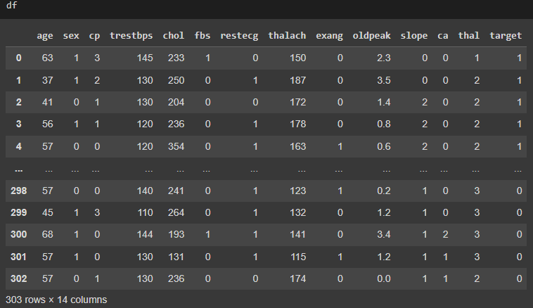

This can be viewed from first or last rows. The following command shows the first 5 rows:

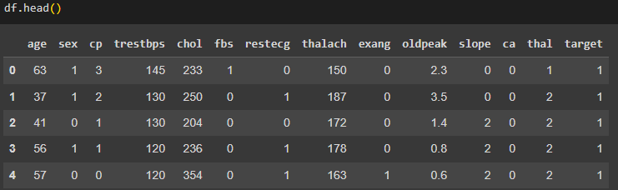

Similarly we can view the data from last 5 rows:

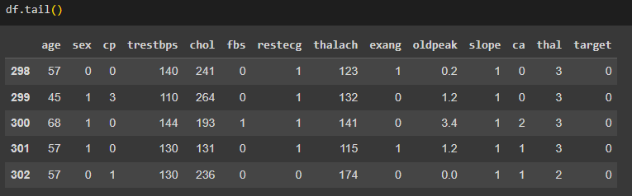

**Specific Row Search:**

We can also search for data in specific location.



The data within a range can also be viewed using start_location : end_location format

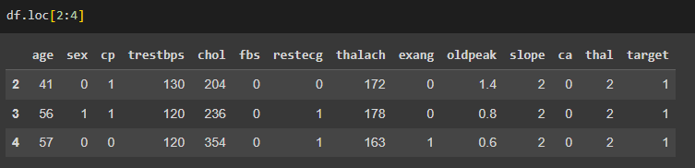

Adding a column name after range with a comma will show us only the column value of the given range. Let’s say we want to see the thalach column from row 1 to 4, here’s how to view it

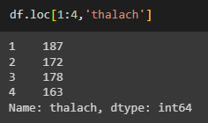

**Data information:**

We can also check the data types of the columns:

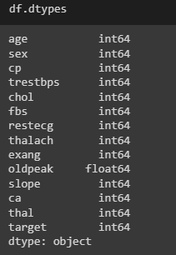

If we want to get a complete information about the data in the file we can type name.info() to find it

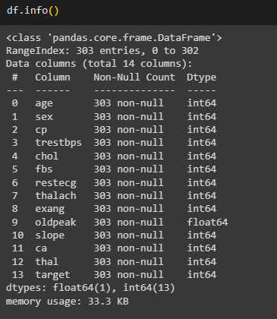

**Counting operations:**

We can perform different counting operation on the given file. We can check the number of null values on each column

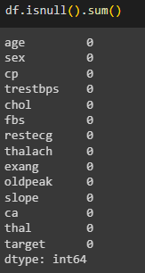

We can also count the appearance of a value in the file and store it in a variable. Then print the variable to show the result

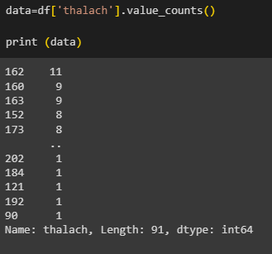

**Minimum and maximum:**

The max(file_name.column) returns the max value for the column



Similarly we can find the minimum of the column



**Other operations:**

We can find unique values on a column with the following code:

